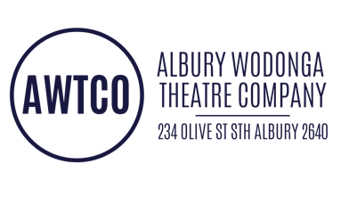
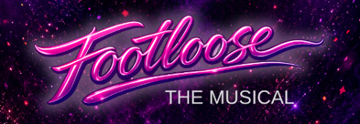

Auditionee #

PERSONAL DETAILS

First Name:

Last Name: Phone:
D.O.B:
Address:
Email:
AUDITION FORM

EMERGENCY CONTACT

Name: Phone:

PREVIOUS THEATRICAL EXPERIENCE (Most recent or most notable)

YEAR | SHOW | ROLE | COMPANY
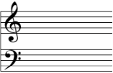
VOCAL RANGE | □ Soprano
(If unknown, please leave blank) | □ Alto
 | □ Tenor
 | □ Bass

WHICH ROLE/S ARE YOU AUDITIONING FOR? (Please Tick)

□ Principal Character □ Any On-stage Character □ Featured Dancer □ Ensemble □ Back Stage
HOW WOULD YOU DESCRIBE YOUR PART SINGING / HARMONY SINGING CAPABILITY?
□ Unsure □ Beginner □ Moderate □ Experienced
Are you currently involved in any other productions? □ NO □ YES (please specify)
Give details:______________________________________________________________________

CONDITIONS OF AUDITIONING
Prior to auditioning you will be asked to complete and sign this audition form. By signing this form, you are agreeing to a full commitment to the show, which includes the following:
- I understand that if my audition is unsuccessful, I must accept and respect the final decision of the production team. Any further discussion about the audition process must be made formally through the Secretary of AWTCO: ben@awtco.org.au
- I will be available for rehearsals on the days and times scheduled by the Director.
- I understand that if I fail to attend more than two rehearsals without approval from the production team my role in the production could be terminated.
- I understand that I may be required to be available for Media Calls outside of rehearsals times.
- I understand that I am part of a team and am required to attend occasional working bees to assist the progress of the show.
- I understand I may be asked to arrange to complete aspects of my own costumes.
- I understand that my commitment to the show is complete and the “show must go on”.
- I understand that my costumes, makeup and hair designs will be determined by the respective production staff, and I agree to abide by their artistic requirements.
- I agree to pay the appropriate show membership fee. Show-related clothing and accessories (eg. T-Shirts or Hoodies) are voluntary additional purchases with orders taken by the production team early in the rehearsal schedule.
- I understand that punctuality to all rehearsals, events and performances will be expected.
- I will be responsible for the condition of any items allocated to me as part of the production (e.g. Costumes). I will be responsible for paying the replacement cost for any lost and damaged items.
If you cannot comply with all these requirements, please discuss with the Producer prior to auditioning.

Media Consent

I hereby grant permission to Albury Wodonga Theatre Company (AWTCo) and its agents to use photographs and/or video and/or audio taken of me. These types of media may be used as part of the audition process and additionally in educational and documentary materials such as Public Service Announcements, Grant Applications, Video Documentaries and both printed and online newsletters. Furthermore, I authorise the use of my image, likeness and voice for all program promotion, materials and any other purpose in connection with the program deemed appropriate and necessary for the production.

I hereby agree to release, defend and hold harmless, AWTCo and its agents, including any firm publishing and/or distributing the finished product in whole or in part, whether on paper, via electronic media or on websites, from any claim, damages or liability arising from or related to the use of photographs/video, including but not limited to any misuse, distortion, blurring, alteration, optical illusion or use in composite form, either intentionally or otherwise that may occur or be produced in taking, processing, reduction or production of the finished product, its publication and/or distribution.

I am 18 years of age or older [if under 18 years of age, please ensure the information below is completed by a parent/guardian] and have read this release before signing below, fully understanding the contents, meaning and impact of this release. I understand that I am free to address any specific questions regarding this release by submitting those questions in writing prior to signing and I agree that my failure to do so will be interpreted as a free and knowledgeable acceptance of the terms of this release.

Signature: Date: / /

